**Question # 1:**

Routing is the process of selecting a path for traffic in a network or between or across multiple networks and it’s performed by layer 3 (or network layer) devices in order to deliver the packet by choosing an optimal path from one network to another. There are 3 types of routing:

* Static routing
* Default Routing
* Dynamic Routing

**Question # 2:**

Static routing is a process in which we have to manually add routes in routing table. Some advantages of static routing are stated below:

* It causes very little load on the CPU of the router, and produces no traffic to other routers.
* It leaves the network administrator with full control over the routing behavior of the network.
* It is very easy to configure on small networks.

**Question # 3:**

Default routing is a method where the router is configured to send all packets towards a single router (next hop) and is generally used with stub routers. In networks other than stub networks, if a packet is received on a routing device, the device first checks to see if the IP destination address is on one of the device’s local subnets. If the destination address is not local, the device checks its routing table. If the remote destination subnet is not listed in the routing table, the packet is forwarded to the next hop toward the destination using the default route.

**Question # 4:**

DCE stands for Data Communications Equipment, and DTE stands for Data Terminal Equipment

**Question # 5:**

OSPF stands for Open Shortest Path First. Metrics are cost values used by routers to determine the best path to a destination network. Several factors help dynamic routing protocols decide which preferred or shortest path to a particular destination. The most common metric values are hop, bandwidth, delay, reliability, load, and cost.

**Question # 6:**

**Subnet mask**: A 32-bit combination used to describe which portion of an address refers to the subnet/network and which part refers to the host. It is used along with IP Address.

**Wildcard mask:** indicates IOS software whether to check or ignore corresponding IP address bits when comparing the address bits in an access list entry and sometimes referred to as an inverted mask because a 1 and 0 mean the opposite of what they mean in a subnet (network) mask.

**Question # 7:**

**Distance Vector Routing:** The routing share, the information of the entire autonomous system and the information is shared only with neighbors.

* Bellman-Ford algorithm is used for performing distance vector routing.
* Distance vector routing calculates the best route based on the distance (fewest number of hops).
* Distance vector routing updates full routing table.

**Link State Routing:** The routers share the knowledge only about their neighbors and the information is shared with all routers

* Dijkstra is used for performing the link state routing.
* Link state routing calculates the best route on the basis of least cost.
* Link state routing updates only the link state.

The utilization of CPU and memory in distance vector routing is lower than the link state routing.

**Question # 8:**

RIP (Routing Information Protocol) and IGRP (Interior Gateway Routing Protocol) is a commonly used distance vector protocol that uses hop counts or its routing metrics.

OSPF (Open Shortest Path First) protocol and intermediate system to intermediate system (IS-IS) is the example link state routing.

**Question # 9:**

Access-list (ACL) is a set of rules defined for controlling the network traffic and reducing network attack. ACLs are used to filter traffic based on the set of rules defined for the incoming or outgoing of the network.

There are two main different types of Access-list namely

* Standard Access-list
* Extended Access-list

Furthermore, there are two categories of access list which are

* Numbered access list
* Named access list.

**Question #10:**

Access Control List (ACL) is placed/configured on the routers to filter the traffic based on source IP address.

ACL can apply in outbound, inbound , and VCL , ACL on arriving and leaving ends , but It cannot be applied on in internal traffic.

Step No 1:

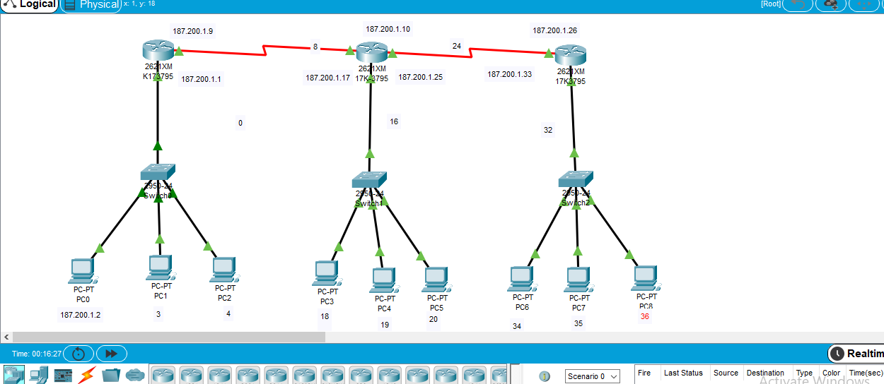

**Topology**

**LAB A ROUTER IP ADD AND SUBNET Fa0/0 & Serial 0/0**

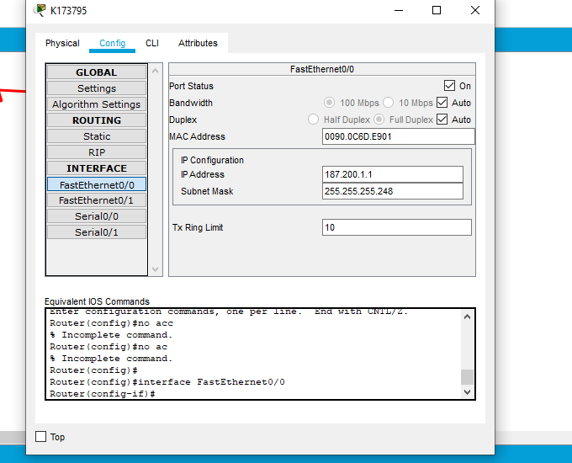

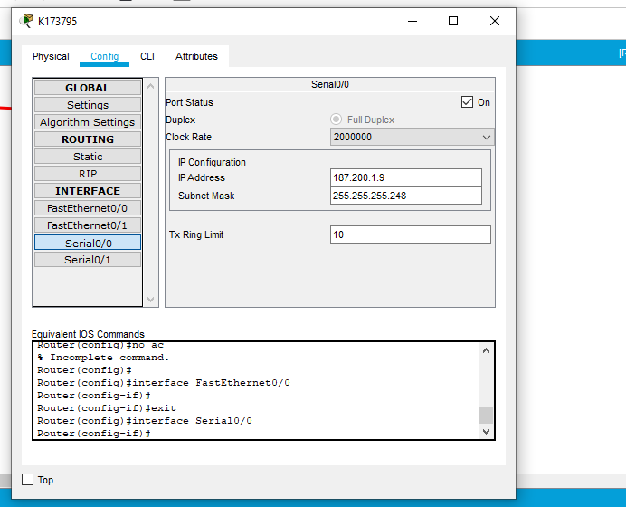

**LAB B ROUTER IP ADD AND SUBNET Fa0/0, Serial0/0 and Serial0/1**

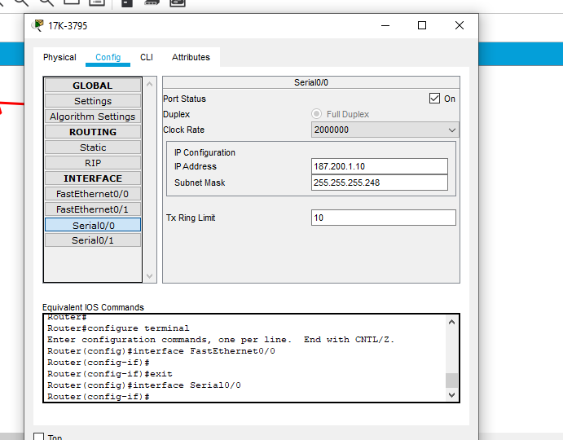

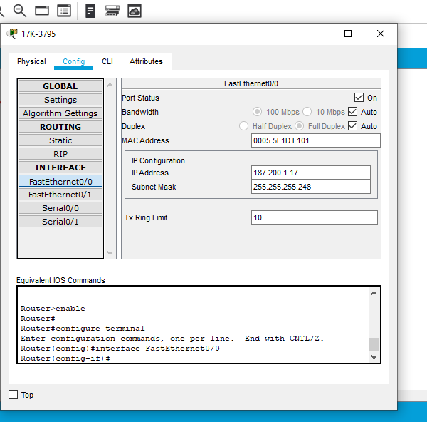

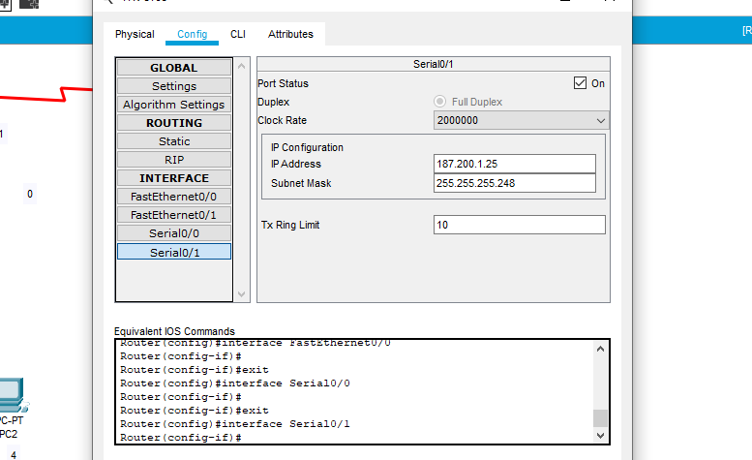

**LAB C ROUTER IP ADD AND SUBNET Fa0/0 and Serial0/0**

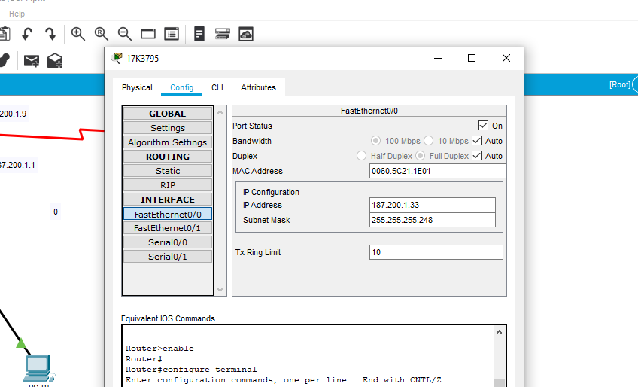

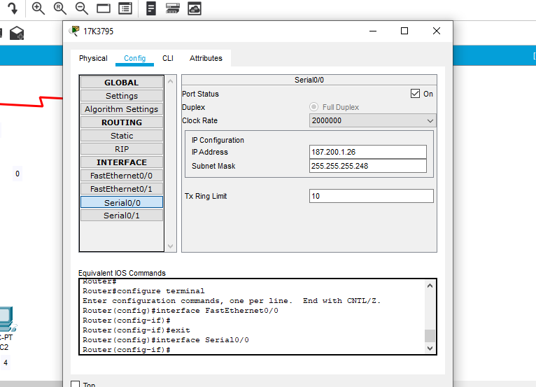

**SHOW IP ROUTE**

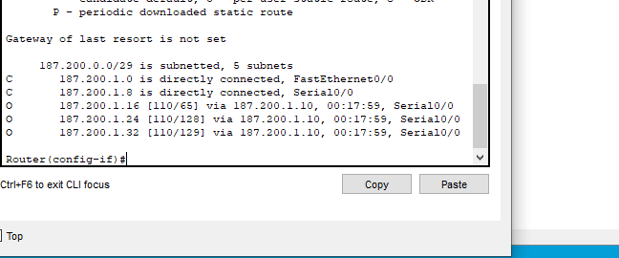

**SUCCESSFUL MESSAGE PASSING**

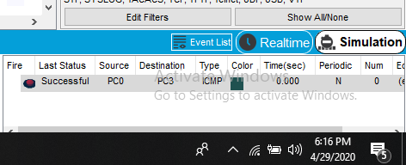

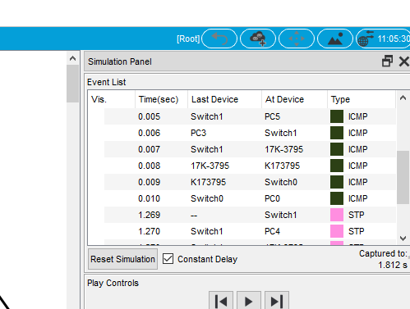

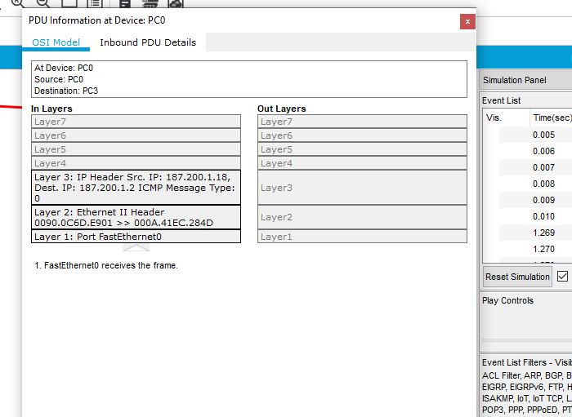

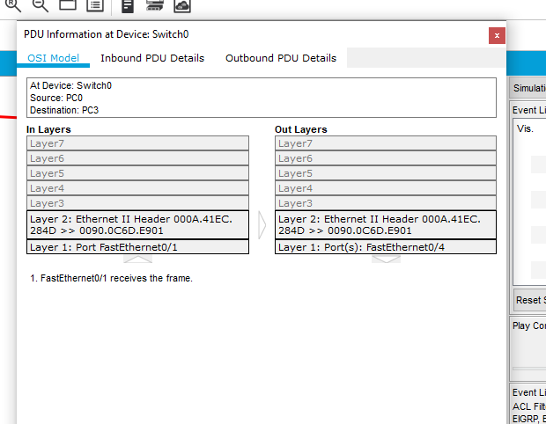

**STEP NO 2 ACL:**

**For part a configure LAB A router**

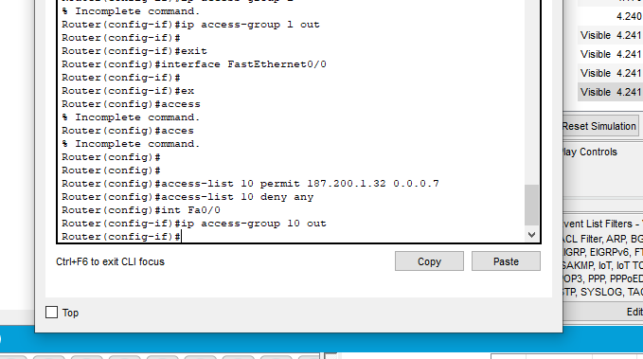

MESSAGE FAILED FROM LAB A TO B

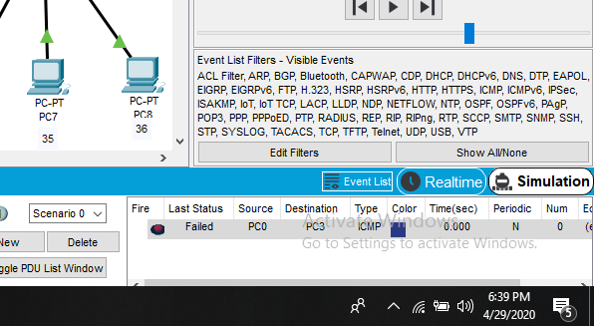

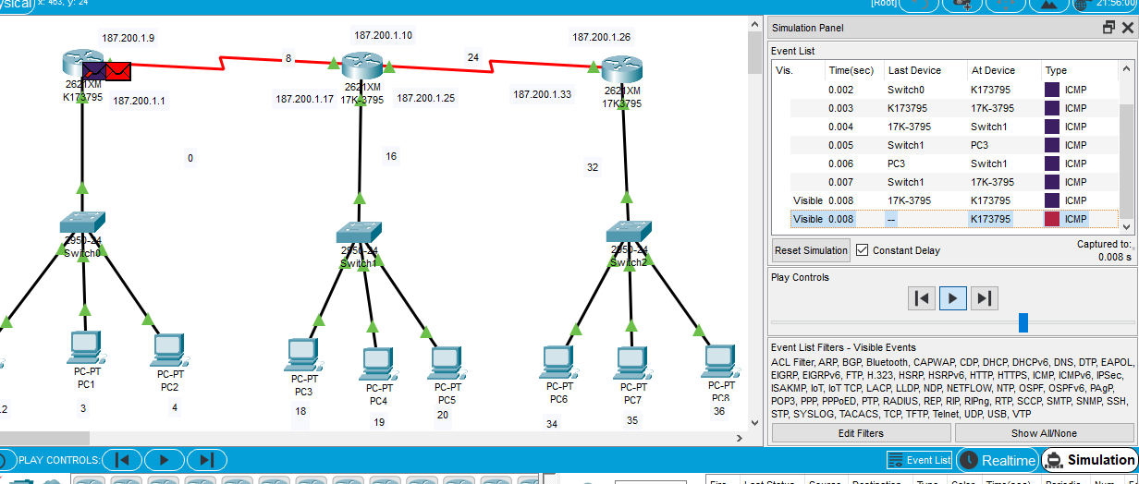

MESSAGE SUCCESS FROM LAB A TO C

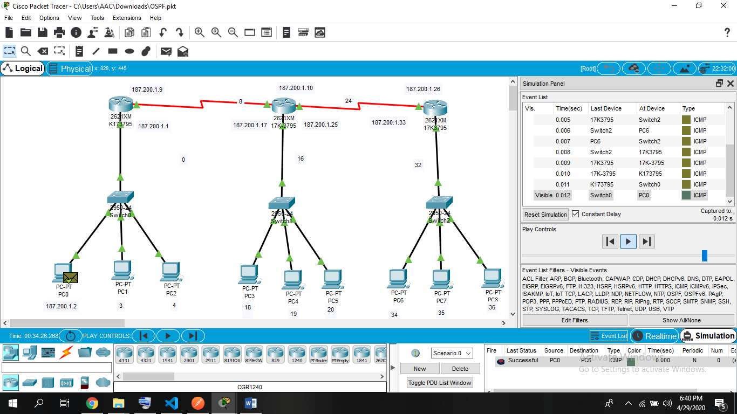

**For part b configure LAB C router**

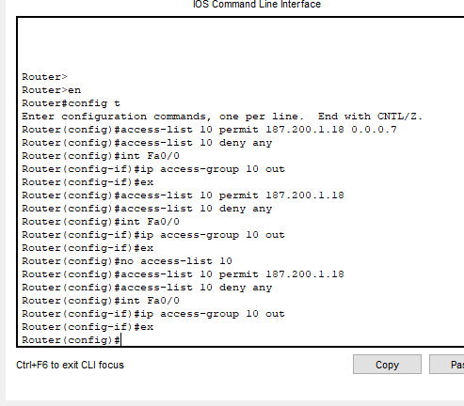

**MESSAGE SUCCESS FROM PC3 TO PC6 (lab C)**

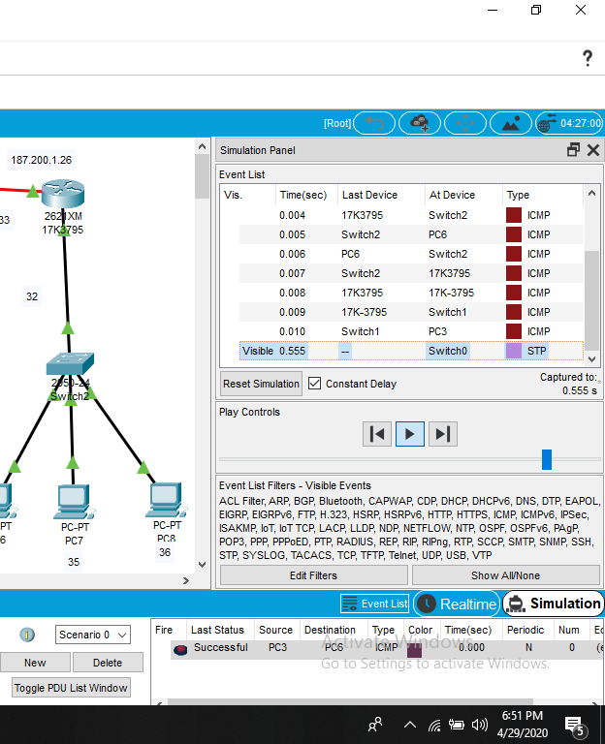

**MESSAGE FAILED FROM PC4(LAB B) TO PC6(LABC)**

